Exercise 1: Implementing the Singleton Pattern
using System;
class Singleton
{
private static Singleton instance;
private Singleton()
{
Console.WriteLine("Singleton Instance Created");
}
public static Singleton GetInstance()
{
if (instance == null)
{
instance = new Singleton();
}
return instance;
}
public void ShowMessage()
{
Console.WriteLine("Hello from Singleton Object");
}
}
class Program
{
static void Main(string[] args)
{
Singleton obj1 = Singleton.GetInstance();
Singleton obj2 = Singleton.GetInstance();
obj1.ShowMessage();
if (obj1 == obj2)
{
Console.WriteLine("Both objects are the same instance.");
}
else
{
Console.WriteLine("Objects are different.");
}
}
}

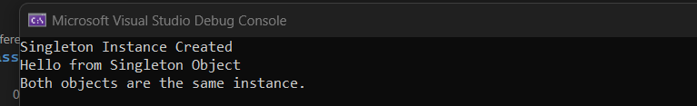

Exercise 2: Implementing the Factory Method Pattern
using System;
interface IVehicle
{
void Drive();
}
class Car : IVehicle
{
public void Drive()
{
Console.WriteLine("Driving a Car");
}
}

class Bike : IVehicle
{
public void Drive()
{
Console.WriteLine("Riding a Bike");
}
}
class VehicleFactory
{
public static IVehicle GetVehicle(string type)
{
if (type.ToLower() == "car")
return new Car();
else if (type.ToLower() == "bike")
return new Bike();
else
return null;
}
}

class Program
{
static void Main()
{
Console.Write("Enter vehicle type (car/bike): ");
string type = Console.ReadLine();
IVehicle vehicle = VehicleFactory.GetVehicle(type);
if (vehicle != null)
vehicle.Drive();
else
Console.WriteLine("Invalid vehicle type.");
}
}

